(Title)

Ashil Sayyed Farahmand

Thesis submitted to the faculty of the Virginia Polytechnic Institute and State University in partial fulfillment of the requirements for the degree of

Master of Science
In
Electrical Engineering

Lamine Mili
Shinya Kikuchi
Daniel Stilwell

January 2008
Falls Church, VA

Keywords: collision avoidance, EKF, extended kalman filter, AVCS, advanced vehicle control systems, ITS, intelligent transportation systems

Copyright (Optional)

(Title)

Ashil Sayyed Farahmand

ABSTRACT

(Enter abstract here)

Acknowledgements

Contents

Acknowledgements iii
Contents iv
List of Figures vi
List of Tables vii
Acronyms viii
Chapter 1 - Introduction 1
1.1 Background 1
1.2 Problems/Limitations 1
1.3 Thesis Overview 1
Chapter 2 - Literature Review 3
2.1 Radar 3
2.2 Optical 3
2.3 Cooperative Collision Avoidance \ MAS(write as separate section?) 3
2.4 Other (Ships, Planes, Robots) 3
Chapter 3 - Vehicle Engine and Powertrain Model 4
3.1 Principles of Automobile Engines and Powertrains 4
3.2 State Space Modeling 6
3.2.1 Control Variables 6
3.2.2 State Variables 8
Chapter 4 - Linearization, Discretization, and the Extended Kalman Filter for Vehicle Modeling 15
4.1 Kalman Filter for Linear Model 15
4.1.1 Prediction 17
4.1.2 Correction\Update 18
4.2 Extended Kalman Filter 19
4.2.1 Linearization 20
4.2.2 Discretization 21
4.2.3 Prediction 24
4.2.4 Correction\Update 25
4.2.5 Implementation 27
4.3 Numerical Integration Techniques 29
4.3.1 Euler Method 29
4.3.2 4th-order Runge-Kutta Method 30
Chapter 5 - Vehicle Network 31
5.1 Vehicle Communication Protocol 31
5.2 Wireless Networking Technologies (VANETs) 31
5.2.1 802.11g 31
5.2.2 WiMAX 31
5.2.3 DSRC\802.11p 31
5.3 Cooperative Vehicle Optimization Algorithm 31
5.3.1 Sparse Traffic 31
5.3.2 Dense Traffic 31
Chapter 6 - Stability Analysis of Vehicle Model and Network 32
6.1 Vehicle Model Stability 32
6.1.1 Equilibrium Points 32
6.1.2 Limit Cycles 32
6.2 Vehicle Optimization Algorithm Stability 32
Chapter 7 - Simulation Results 33
7.1 Simulation Overview 33
7.2 Determination of Vehicle Model Parameters 33
7.3 Determining the Brake Constant of Proportionality 33
7.4 Determining Deceleration as a Function of Brake Angle 33
7.5 Comparison of the Euler and 4th-order Runge-Kutta Methods on Vehicle Model 33
7.6 Simulations of Sparse Traffic Optimization Algorithm 35
Chapter 8 - Conclusions 36
Chapter 9 - References 37
Appendix A 38

List of Figures

Figure 1.1: A Roundabout 1
Figure. 3.1: Normalized Throttle Characteristics with respect to Throttle Angle, plot of actual data and piecewise continuous fit copied from [1], plot of approximate fit overlaid. 7
Figure. 3.2: Definition of Steering Angle 8
Figure 3.3: Normalized Pressure Influence Function as a function of the Pressure Ratio. Plot obtained from [1]. 10

List of Tables

Acronyms
AFI - normalized air fuel influence function
AFR - air/fuel ratio
DSRC - dedicated short-range communications
EFI - electronic fuel injection
EKF - extended kalman filter
MBT - minimum spark advance for best torque
PR - pressure ratio
PRI - normalized pressure influence function
RK4 - 4th-order Runge-Kutta
TC - normalized throttle characteristics
SA - spark advance/retard from top dead center
SI - normalized spark influence function

Chapter 1 - Introduction

1.1 Background
The invention of the automobile has allowed people to travel long distances at an unprecedented rate. Initially, vehicle ownership was limited to the rich. However, once mass production began in the 20th century, automobile ownership skyrocketed. The resulting traffic increase and contention at road junctions inspired the creation of new devices to prevent vehicle collisions. Roundabouts, stop signs, yield signs, and traffic signals began to be installed at intersections.

Roundabouts - how work, when to install them, different types

Figure 1.1: A Roundabout

Yield and Stop signs - how stop signs work, when to install them, when to upgrade to light

Traffic signal - timed, semi-actuated, fully actuated, when to install

1.2 Problems/Limitations
The existing intersection control devices are no good because they don't adapt.

1.3 Thesis Overview

(say something about coupled kalman filters)
The research conducted in this thesis seeks to improve upon the performance of current intersection control devices, specifically, traffic signals, stop signs, and yield signs, by proposing a decentralized, adaptive, cooperative collision avoidance system that acts as a traffic signal in dense traffic and as a yield sign in sparse traffic.

In an effort to improve upon other proposed collision avoidance systems that use linear, ideal models, each vehicle is modeled as a nonlinear five state variable model that accounts for the vehicle's physical characteristics and internal engine parameters. The system has each vehicle measure its own state information using sensors. The state information of other vehicles is obtained by receiving data through a wireless communication link. An Extended Kalman Filter is then used to achieve a more precise estimate of the state information from these noisy measurements. The filtered state information is used to determine the optimal trajectory each vehicle should take to minimize the average delay of the vehicles in the intersection.
Chapter 2 - Literature Review

2.1 Radar

2.2 Optical

2.3 Cooperative Collision Avoidance \ MAS(write as separate section?)

2.4 Other (Ships, Planes, Robots)

Chapter 3 - Vehicle Engine and Powertrain Model

The first section of this chapter is intended to provide the reader a presentation of the physical operation of automobile engines and power trains. It is intended to be not a thorough discussion of all internal devices but to provide a sufficient background for understanding this thesis. The following section will present the differential equations governing the dynamics of the vehicle.

3.1 Principles of Automobile Engines and Powertrains
Conventional automobiles generate vehicle motion by burning a mixture of fuel and air. The internal combustion engine is responsible for converting the chemical energy of fuel into vehicle kinetic energy. The power train converts the output of the engine to the appropriate torque and rotational speed before transferring the power to the wheels. This section will provide a detailed discussion of how this process occurs.

The conversion process begins at the throttle. It adjusts the throttle valve which directly controls the amount of air being allowed into the engine's intake manifold. The intake manifold is responsible for regulating airflow to the individual engine cylinders. In naturally-aspirated engines, the pressure of the intake manifold never exceeds the ambient atmospheric pressure. (Discuss turbo + supercharging?) The pressure difference creates a stream of air through the manifold to the cylinders.

(Talk about engine cycle? intake/compression/power/exhaust) (If discussing cylinder configurations, insert here) The engine cylinders are the location where fuel combustion occurs. The cylinders receive air through a valve from the intake manifold. (Discuss fuel injection methods?) The electronic fuel injection (EFI) system mixes the fuel with the air prior to combustion. The type of EFI determines when the fuel is mixed with air. In sequential EFI (also known as multi-port fuel injection), fuel is injected at the exit of the intake manifold as air enters each cylinder for combustion.

The EFI system is also tasked with deciding the amount of fuel to inject. Using an oxygen sensor to measure the composition of gases in the exhaust, it adjusts the amount of fuel to achieve the optimal air/fuel ratio (AFR) during combustion. In terms of mass, an AFR of 14.7:1 results in complete combustion of air and fuel assuming the fuel is pure heptane. Different AFRs may be desired for a variety of reasons depending on the operating conditions.

After combustion occurs in the cylinders, the linear-reciprocating motion of the pistons is converted to rotational motion using a crankshaft. The crankshaft then connects to a flywheel. The flywheel acts as a stabilizing mechanism by smoothing the discrete firings of the pistons into a more continuous rotation. The engine angular velocity and output torque at the flywheel are often inappropriate for direct application to the wheels. The conversion to more appropriate values is performed by the transmission.

The transmission is composed of a gear box and typically in automatic transmissions a torque converter. The torque converter provides fluid coupling and increased torque during initial acceleration. It is composed of at least three rotating elements: a pump, a turbine, and a stator. The input of the converter, the pump, is directly connected to the engine and rotates at engine speed. The output of the converter, the turbine, is connected to the wheels through the gear box. The stator sits between the pump and turbine. When there is a substantial difference between the pump and turbine rotational velocities (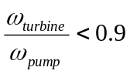), the torque converter is in converter mode. In this mode, the torque converter provides torque multiplication to the output by acting as an additional gear. When the pump and turbine angular velocities are nearly equivalent, the torque converter locks and is in fluid coupling mode [1]. The fluid coupling increases the fuel efficiency of the vehicle. Similar to the function of the flywheel, the fluid coupling also smoothes the rotational speed applied from the pistons to the wheels [Wikipedia].

The gear box of a typical car has four or five gears of fixed size. In an automatic transmission, the vehicle adjusts gears by itself. (Talk about different transmission types?) The gears are sized so that high torque is transferred to the wheels during low velocities and high rotational speed during high velocities. The highest gear is often called the overdrive gear. It significantly increases fuel efficiency at high speeds. When first introduced, the overdrive was a different device housed separately from the rest of the gears but in current vehicles the term is simply used to refer to the highest gear.

3.2 State Space Modeling
The state space vehicle model is based on tabulated data for a 1990 Lincoln Town Car. The model is basically a form of the 3 state variable model derived in [1] with portions from other sources. The vehicle modeled herein is a typical 6 cylinder, front-wheel drive car with a Ford AOD, continuous, four-stroke, spark-ignition engine. This model expands upon the original model and uses 3 control and 5 state variables.

3.2.1 Control Variables
The model's control variables represent the accelerator, brake, and steering wheel. The variables and their notations are shown in Table 3.1.
Table 3.1: Control Variables and Associated Notations.
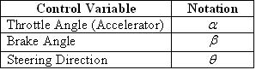

The throttle directly controls the air entering the intake manifold. Since the actual relationship between the two variables is highly nonlinear, an approximate fit based on empirical data is used. The approximate fitted normalized throttle characteristic is defined as
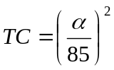. (1)

The effect of the throttle angle on the mass of air entering the intake manifold is shown in Fig. 3.1.

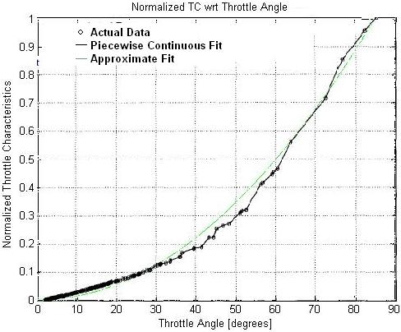

Figure 3.1: Normalized Throttle Characteristics with Respect to Throttle Angle, plot of actual data and piecewise continuous fit copied from [1], plot of approximate fit overlaid.

The brakes control the amount of pressure applied by the brake pads to the wheels. When the brakes are engaged, a torque opposing the motion of the car is created. In conventional vehicles, this causes the vehicle to dissipate energy in the form of heat and decelerate. Through simulations on the state space vehicle model used in this thesis, it was found that
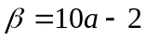, (2)

where  is in degrees and is the deceleration rate in m/s.

The steering direction controls the destination of the vehicle. Like the angles of the unit circle, it has been defined as the angle from the positive x₁ axis as shown in Fig. 3.2.

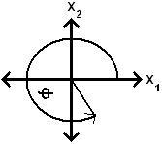

Figure 3.2: Definition of Steering Angle

3.2.2 State Variables
The state variables of the vehicle are of a number of five; these include the x₁-coordinate position, x₂-coordinate position, mass of air in the intake manifold, engine angular velocity, and brake torque. The variables along with their notations are shown in Table 3.2.
Table 3.2: State Variables and Associated Notations
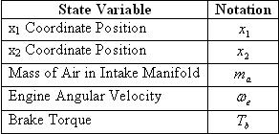

Each vehicle determines its position using GPS. When vehicles come within wireless communication range, each periodically shares its states along with other necessary information with the others. Since these measurements are noisy and communication packets may be lost in transit, it is useful to independently track other vehicles' positions by using velocity for comparison with the GPS measurements. This is carried out as follows: the velocity of a vehicle is given by
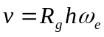, (3)

where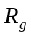 is the gear reduction ratio, a gear-dependent constant, and h is the effective tire radius. Using this equation, it follows that the differential equations for the x₁ and x₂ positions are given by
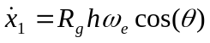, (4)
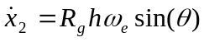. (5)

The differential equation for the next state variable, the mass of air in the intake manifold, is given by
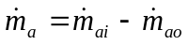, (6)

where 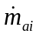 and 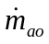 are the mass flow rates of air in and out of the intake manifold. The mass flow rate of air into the intake manifold is dependent on the throttle angle and the pressure difference between the atmosphere and the intake manifold. These dependencies are reflected in its equation
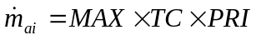. (7)

MAX, a vehicle-dependent constant, is defined as the maximum flow rate of air corresponding to a fully opened throttle valve. The effect of the throttle angle is represented by the normalized throttle characteristic defined in Equation 1. PRI, the normalized pressure influence function, represents the effect the pressure difference has on the incoming mass flow rate. A plot of 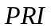 for the specific vehicle used in this thesis is shown in Fig. 3.3.
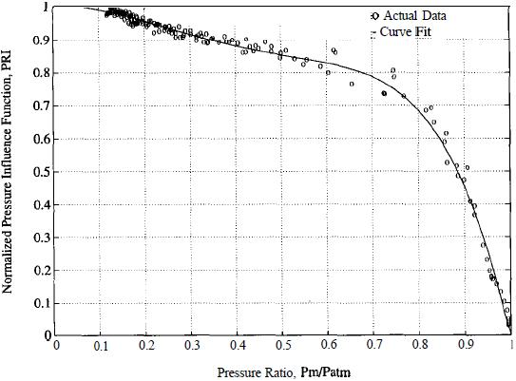

Figure 3.3: Normalized Pressure Influence Function as a function of the Pressure Ratio. Plot obtained from [1].

Due to its nonlinear nature, the curve fit in Figure 3.3 has been used. Its functional form is given by the polynomial
(8)

where 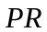 is the pressure ratio. is defined as the ratio between the pressure in the intake manifold and the atmosphere and is given by
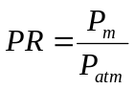. (9)

Using the Ideal Gas Law, the manifold pressure is given by
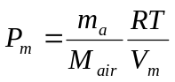, (10)

where  is the ideal gas constant, is the manifold temperature, 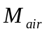 is the molecular mass of air, and 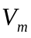 is the volume of the intake manifold.

Now that 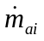 has been analyzed, the differential equations governing the mass flow rate of air exiting the manifold will be studied. Since the air leaving the manifold is directly used for combustion, its mass is dependent on the amount of work the engine is performing. The differential equation for the mass flow rate of air leaving the intake manifold is
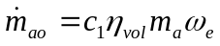, (11)

where 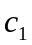 is a physical constant and 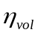 is the volumetric efficiency [1]. is given by
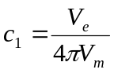, (12)

where 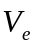 is the constant engine displacement. The volumetric efficiency describes the engine's ability to draw fresh air into the cylinders for combustion. It is a measure of the percentage of air and fuel that is drawn into the cylinder relative to the maximum amount that can be drawn during static conditions [Wikipedia]. It is common for fuel-injected vehicles to achieve efficiencies greater than 90%. Due to the difficulty of precisely modeling the volumetric efficiency, an empirical approximation is used instead. The approximation is given by the equation
[2]. (13)

The engine angular velocity is the next state variable to be analyzed. It is directly controlled by the brake angle and is indirectly controlled by the throttle angle through 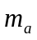. It is also directly proportional to the vehicle speed. Using Newton's Laws, the engine angular velocity is given as the solution of
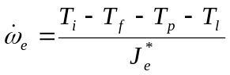, (14)

where 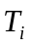 is the engine indicated torque, 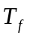 is the engine friction torque, 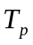 is the engine pump torque, 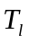 is the load torque, and 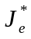 is the effective engine inertia. The torque variables in Equation 14 represent a variety of forces acting on the vehicle. represents the gross power generated by combustion in the engine cylinders. includes internal friction in the engine and power train while accounts for losses in the torque converter. The load torque is dependent on a number of factors including the amount of pressure on the brakes, the rolling resistance of the vehicle, and aerodynamic drag. The effective engine inertia is a gear dependent constant given by
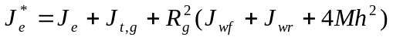, (15)

where 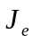 is the engine and torque converter inertia, 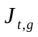 is the transmission inertia in gear (a gear dependent constant), 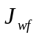 and 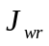 are the combined inertias of the front and rear wheels respectively, and  is the mass of the vehicle. The equation yielding the engine indicated torque is
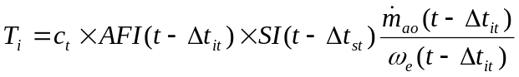, (16)

where 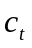 is the engine torque constant (the maximum torque capacity of an engine for a given air mass and engine speed), 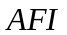 is the normalized air fuel influence function, 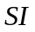 is the normalized spark influence function, 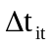 is the intake-to-torque production delay, and 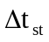 is the spark-to-torque production delay [1]. Assuming negligible time delays associated with engine power production, Equation 16 simplifies to
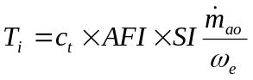. (17)

The normalized air fuel influence function is directly dependent on the AFR and is given by
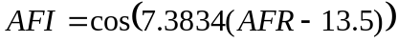. (18)

models the effect that ignition spark timing has on the engine torque production. The normalized spark influence function is given by
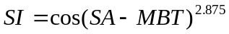, (19)

where 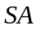 is the spark advance/retard from top dead center and the constant 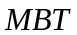 is the minimum spark advance for best torque [2]. Now that the engine's torque generation has been studied, the sources of energy loss are analyzed. The engine friction torque has been approximated from empirical data and is given by
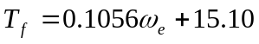 [2]. (20)

The torque converter's torque in converter mode is given by
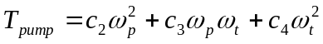, (21)
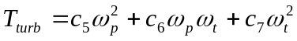 , (22)

where 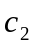 through 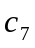 are constants. As the converter locks and transitions to fluid coupling mode, the torques become equal and are given by
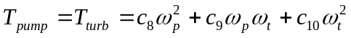, (23)

with 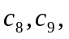 and 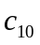 as constants. Since the pump rotates at the engine angular velocity and the turbine rotates as at the same rate as the pump in fluid coupling mode, the torque equation simplifies to
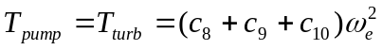. (24)

The final torque in the engine angular velocity differential equation, the load torque, is given by
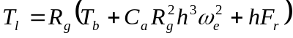, (25)

where 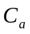 is a constant accounting for the aerodynamic drag coefficient and the constant 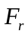 is the combined rolling resistance of the wheels.

The final state variable, the brake torque, is now analyzed. Unlike the other states, the brake torque is described by the following linear differential equation:
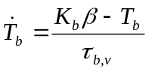. (26)

The brake torque constant of proportionality, 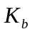, is directly related to the sensitivity of the brakes to pressure from the brake pedal. 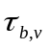, the brake system time constant, models the delay between pressure on the brake pedal and the application of the brake pads to the wheels.

Chapter 4 - Linearization, Discretization, and the Extended Kalman Filter for Vehicle Modeling

The Kalman Filter is a mathematical tool that estimates state information from noisy measurements. Although the filter may be formulated in different ways, this thesis will focus on the computationally-efficient recursive form. This chapter will introduce the Kalman Filter and discuss its governing equations. In the next section, the Extended Kalman Filter (EKF) will be presented and its application to the research conducted in this thesis will be explained. The following sections will discuss specific implementation methods.

4.1 Kalman Filter for Linear Model
The classical Kalman Filter is a discrete-time, time domain filter used to estimate the states of linear, dynamic systems. Each iteration, it predicts the next state of the system using all past observations, receives a new observation corrupted by noise, then makes a corrected estimate of the system's state by comparing the new observation to all past observations. The filter models each state transition as
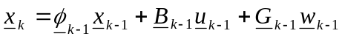, (27)

where is the state vector, is the state transition matrix, 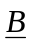 is the control-input matrix, is the control vector, 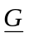 is the noise-coloring matrix, and 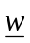 is the process noise. The state transition matrix describes how the system states change when no external inputs are applied. It is a significant indicator of the system's stability *** (eigenvalues on left side then stable, converges). The transition matrix has the following properties:
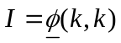, (28)
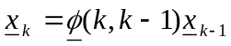, (29)
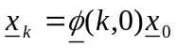, (30)
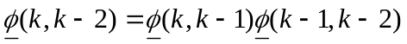, (31)
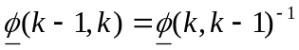 [Gelb]. (32)

The control-input matrix controls the effect of the inputs on the states. The noise-coloring matrix shows how noise affecting one state will create more noise on another state. The process noise is a vector of independent, white, normally-distributed random variables with zero mean and covariance defined by the matrix 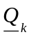. The process noise models state variations in a system (i.e. a rolling vehicle's velocity varies slightly depending on the number of bumps on a road). Usually, the sources of variation are not large enough to warrant a more complex model so they are treated as noise. The Kalman Filter models each observation as
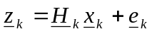 (33)

where 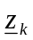 is the observation vector, 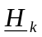 is the observation matrix, and 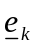 is the observation noise vector. The observation matrix converts the states to the value of the parameter observed. Although the states are being estimated, the state may not be directly observable so another physical quantity may be observed instead (i.e. using a thermocouple to observe voltage as an indicator of the temperature). The observation noise, like the process noise, is a vector of independent, white, normally-distributed random variables with zero mean and covariance 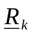. The observation noise models variations in sensor measurements. The process and observation noises have the following properties:
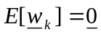, (34)
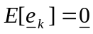, (35)
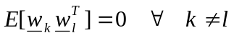, (36)
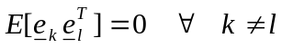, (37)
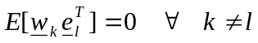. (38)

Before the Kalman Filter may begin estimating, the noise covariances and states must be initialized. The certainty of the initial state 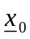 is reflected in 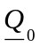. The Kalman Filter uses this value to decide how to correct its estimate during the correction step. The certainty of the observations is reflected in matrix . Since the observations are assumed to be statistically independent of each other, the certainty of one observation is no better than any other so is usually constant for all values of k.

4.1.1 Prediction
The Kalman Filter predicts the next state of the system by making the best possible estimate at the current iteration. The best possible estimate is characterized by minimizing the mean squared error of the prediction. Since the noise is normally distributed, the optimal prediction is given by
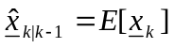. (39)

The equation shows that the predicted state estimate is the expectation or mean value of 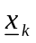. Since the expectation is a linear operator and the expectation of a deterministic variable is equal to that variable, the substitution of the state equation (Eq. 27) into the prediction equation (Eq. 39) yields
. (40)

Since the process noise is defined as having zero mean, the final form of the prediction equation is
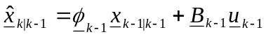. (41)

After making the state prediction, the filter determines the accuracy of the estimate using the covariance of the prediction state error. The prediction state error is defined as
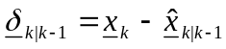, (42)

and its corresponding covariance during the prediction stage is given by (should I show the derivations for the equations in this section?)
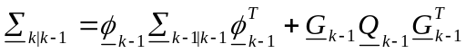. (43)

The Kalman Filter recalculates this quantity in the correction step using observation information.

4.1.2 Correction\Update
The Kalman Filter determines its corrected estimate by comparing the prediction to the observation. When the prediction state error is very low, the filter's corrected estimates are heavily influenced by the predicted estimates rather than the observation information. The influence is instead given to the observations when the prediction state error is high. The Kalman Filter's corrected estimate is given by
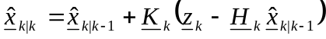, (44)

where 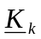 is the Kalman gain matrix and the quantity 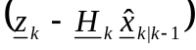 is defined as the innovation. The Kalman gain matrix determines whether the predicted estimate or observations are given more influence in the corrected estimate. The optimal gain is given by
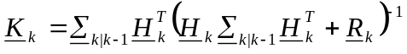 , (45)

where the term 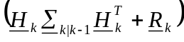 is the covariance of the innovation. The gain is considered optimal because it minimizes the following objective function:
[Mili]. (46)

Once the corrected estimate is found, the predicted state error is calculated by
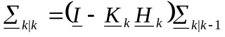. (47)

4.2 Extended Kalman Filter
The EKF is a generalized form of the classical Kalman Filter used to estimate the dynamics of nonlinear systems. The formulation of the EKF presented here is based on [Mendel]. It relies on two models, one nonlinear, another linear, as opposed to only a linear model used in the classical Kalman Filter. The nonlinear model is used directly in the prediction stage. In the correction stage, a linearization is performed on the nonlinear model around the previous corrected estimate to obtain a set of linear perturbation equations. The classical Kalman Filter correction equations are then used as a basis for the EKF correction equations. The EKF state and observation equations are given by
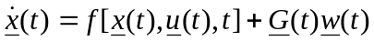, (48)
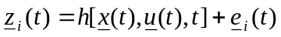, (49)

respectively, where 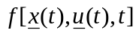 and 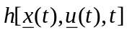 are functions of the state vector, the control vector, and either implicitly or explicitly a function of time. It is also assumed that both  and are continuous and continuously differentiable with respect to all elements of the state and control vectors. The state and control vectors are assumed to be continuous while the process noise is assumed to be a continuous, white noise process. The observations in Eq. 49 are treated as being obtained at discrete intervals. The process and observation noise covariances are given in the equations
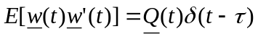, (50)
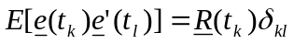, (51)

where 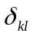 is defined as the Kronecker delta function. It is important to note that the quantity 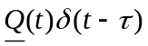 and 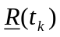 are the covariance matrices while 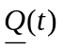 can be referred to as an intensity matrix [Mendel]. The noises also have the same characteristics shown in Eqs. 34-38 for the classical Kalman Filter: they have zero mean, are uncorrelated to themselves in time, and are uncorrelated to each other in time.

4.2.1 Linearization
The EKF linearizes the nonlinear equations to obtain a set of linear perturbation equations. The linearization method used here is the first-order Taylor series expansion. Application to the nonlinear equation yields
, (52)

where
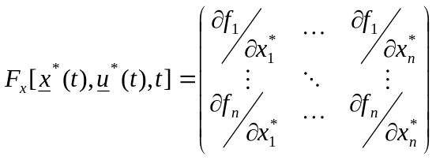, (53)

and the term 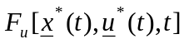 is defined as
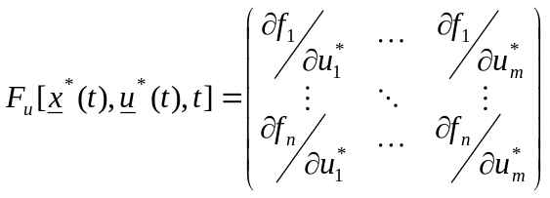. (54)

The variables and are defined as the number of state and control variables respectively. The partial derivatives used in Eq. 53 are defined as
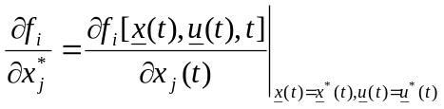. (55)

In Eq. 54, the partial derivatives are similarly defined as
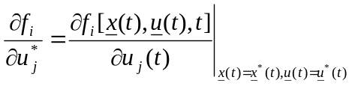. (56)

The terms 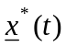 and 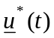 are defined as the nominal state and control vectors respectively. For the first iteration, these values are none other than the initial conditions. For successive iterations, the corrected estimates of the previous iteration are assigned as nominal values. The perturbation from the nominal value represented by 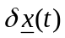 is defined as
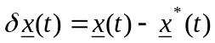, (57)

where the nominal state vector satisfies the equation
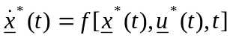. (58)

In the application of the first-order Taylor series approximation in Eq. 52, it is assumed that higher order terms are negligible. This assumption is justified when state and control vector perturbations are small. By substituting the linearization (Eq. 52) into the nonlinear state equation (Eq. 48), the linear perturbation state equation is given by
, (59)

It is necessary for the nominal value to provide a good approximation to the actual value, otherwise, the linear perturbation equations will not accurately model the true behavior of the system. Repeating the linearization on the nonlinear observation equation yields the following linear perturbation observation equation:
. (60)

Now, to convert the perturbation state equation to a form that is applicable to the recursive EKF equations, the equation needs to be discretized.

4.2.2 Discretization
The discretization is performed by first finding the solution of the linear perturbation state equation (Eq. 59). The equation will be solved by first finding the homogenous solution, then the particular solution, then proceeding to find the complete solution. Removal of the inputs and noise yields the following homogeneous differential equation:
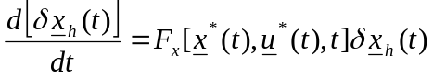. (61)

By utilizing Equation 30, the equation
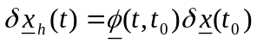, (62)

can be derived, where is the state transition matrix of the linear perturbation state equation. By taking the first derivative, the following equation is obtained:
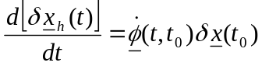. (63)

By substituting Eq. 61 into Eq. 63, an expanded form is given by
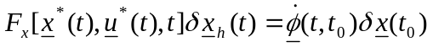. (64)

Now, by substituting Eq. 62 into Eq. 64 and by simplifying out common terms on both sides of the equation, the differential equation yielding the homogeneous solution is given by
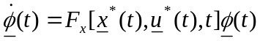. (65)

To find the particular solution, the method of variation of parameters is used. For brevity, the terms 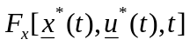 and are denoted by 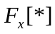 and 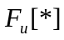 respectively. Let
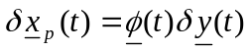, (66)

where 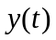 is an unknown 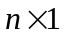 vector. Differentiation of Eq. 66 yields
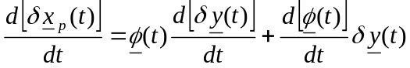. (67)

By equating this with the perturbation state equation (Eq. 59), the following equation is obtained:
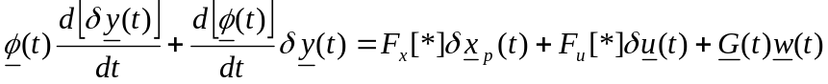. (68)

Substituting Eqs. 65 and 66 into Eq. 68 yields
, (69)

where the simplified form is given by
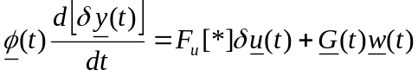. (70)

Since 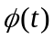 is non-singular [Mendel], its inversion followed by an integration gives
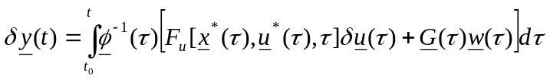. (71)

Substituting Eq. 71 into Eq. 66 gives the particular solution
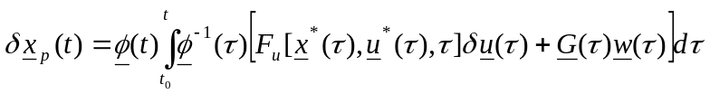. (72)

To find the complete solution, the homogeneous and particular solutions are added to yield
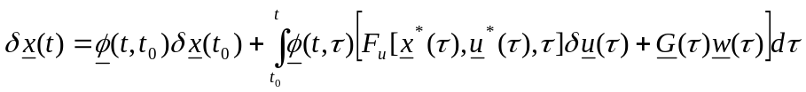. (73)

Now, the solution over one interval is given by
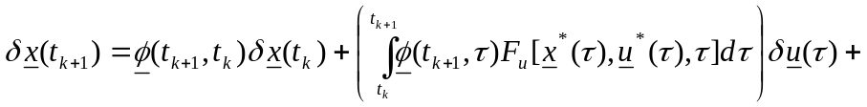
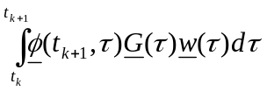. (74)

Converting Eq. 74 to discrete notation and decrementing an iteration to maintain agreement with the form of the EKF equations presented earlier gives the discrete perturbation state equation
, (75)

where the asterisk indicates a functional dependence on the nominal values. The discretized form of the process noise covariance is given by
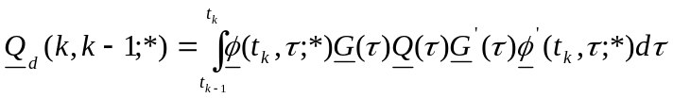. (76)

Since it is assumed that the observations are being received periodically, simply changing the notation of Eq. 60 yields the discrete perturbation observation equation
. (77)

If the expressions , , 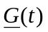, and are approximately constant over one time interval, the solutions for 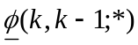, 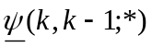, and 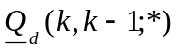 can be greatly simplified. The simplified equations are given by
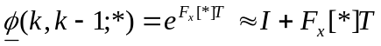, (78)
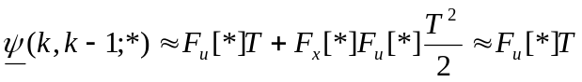, (79)
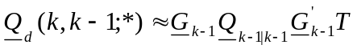, (80)

where is the time of one interval.

4.2.3 Prediction
The EKF prediction equations are similar in form to those of the classical Kalman Filter. However, the EKF needs to be linearized every iteration around the corrected estimates of the previous state. This means that the nominal state is equivalent to the last corrected state
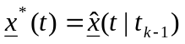, (81)

and as a consequence
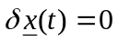. (82)

Replacing the nominal state with the previous corrected estimate in the definition of the nominal state (Eq. 58) yields the differential equation
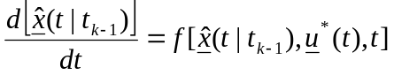. (83)

Subsequent integration results in the EKF prediction equation given by
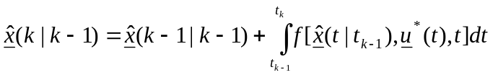. (84)

The function may not have an analytical solution. In section 4.3, some popular numerical integration methods are presented to approximate the definite integral. After calculating the predicted estimate, the covariance of the predicted state error can be determined by the equation
. (85)

4.2.4 Correction\Update
The EKF correction equations are generally based on the discretized linear perturbation equations whereas the prediction equation was based on the nonlinear model. Using the discrete perturbation equations to derive a form similar to the correction equation for the classical Kalman Filter yields
. (86)

The term 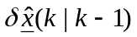 is zero due to linearization around each corrected point. By definition, the perturbation of the correction is given by
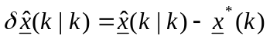, (87)

where
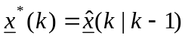. (88)

Applying these changes gives the equation
. (89)

This process is repeated for the perturbation of the observation. By definition,
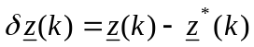, (90)

where
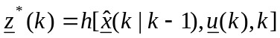. (91)

By combining the results of Eqs. 90 and 91 with 89, the final form of the correction equation is given by
, (92)

where the gain is given by
. (93)

Using the gain and the observation information, the a posteriori predicted state error can be calculated by the equation
. (94)

The presentation of the EKF equations is complete. However, using this form of the EKF may result in convergence problems since performing only one correction may not maintain a small enough perturbation between the true and nominal states thereby causing the model assumptions for Eq. 52 to break down. The recursive method is used here but there are ways to iterate. The EKF correction step is recursively iterated by using the result of the previous correction as the nominal value of the next correction stage. Each iteration involves computation of the following terms:
- and,
- 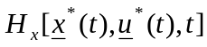 and ,
- ,
- ,
- 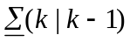,
- 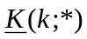,
- 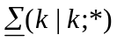.

The iterations cease when the difference between the current correction and previous correction are within a predefined error. The specific stopping method used here is given by
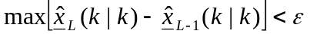, (95)

where is the error and max is the maximum of the difference between the corrected estimates. Other forms of the iterated EKF may opt for the norm of the difference between to two vectors or some other property but the maximum is chosen here to ensure that every state is within the desired error. The filter is designed to produce good results when the system is not highly nonlinear. Otherwise, the EKF can suffer from convergence problems and another form of the Kalman Filter may be preferable.

4.2.5 Implementation
The EKF formulation used to model the vehicle in this thesis is presented here. Since each vehicle estimates its own states as well as the states of each other vehicle, the EKFs of each vehicle need to be coupled. The coupled EKF state vector is just each vehicle's state vector placed together in series. It is defined as
, (96)

where the sixth element is the  coordinate of the second vehicle. Other EKF vectors and matrices are similarly redefined for the coupled EKF.

The prediction stage uses the RK4 method to implement Eq. 84. The predicted state error is calculated using Eq. 85. It is assumed that , , , and are approximately constant over one time interval and that the period between EKF updates is sufficiently small to use the most simplified forms of Eqs. 78-80.

When a vehicle receives observations, all states of each vehicle are directly observed. The goal of using the EKF is to obtain accurate, real-time position and velocity information to avoid collisions. Since the vehicle velocity is dependent on the engine angular velocity, and the engine angular velocity is a function of the mass of air in the intake manifold and the brake torque, all states must be observed. Directly observing the states reduces the real-time computational burden since 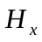 and 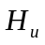 do not have to be calculated separately since they are equal to 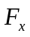 and 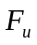 respectively.

The implemented correction stage uses a modified form of Eq. 92. Since the states are directly observed and assuming the controls do not change over one period, the perturbation of the control vector reduces to zero simplifying the correction equation to
. (97)

The other calculations in the correction are left unchanged and implemented as presented.

4.3 Numerical Integration Techniques
Numerical integration techniques are necessary in situations where certain nonlinear equations make finding analytical solutions impossible. In this section, the Euler and 4th order Runge-Kutta (RK4) methods are presented. Afterwards, the performance of each method is analyzed when applied to the EKF prediction equation of the vehicle model. The algorithms presented here are based on [Gerald].

4.3.1 Euler Method
The Euler method is the simplest (and most error-prone) numerical integration technique. Beginning with some initial conditions, it uses a first-order Taylor series approximation of the differential equation to find successive points in the solution. Given a differential equation and a set of initial conditions
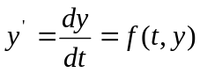, (98)
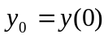, (99)
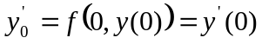, (100)

the Euler method numerically integrates Eq. 66 by using the recursive equation
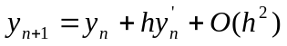, (101)

where is the step size. In essence, the Euler method assumes that the slope over one step is constant and equivalent to the value of the slope at the beginning of the step. Any deviation from this assumption is accounted for as error. The local error, the error introduced in a single iteration, is represented by the term 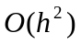 in Eq. 101. The Euler method introduces an amount of local error on the order of 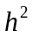. Over numerous iterations, the accumulated local errors produce a global error on the order of .

4.3.2 4th-order Runge-Kutta Method
The RK4 method greatly improves on the Euler method. By approximating the differential equation with a higher order Taylor series, the local and global errors can be significantly reduced. Although it uses a more complex approximation of the differential equation than the Euler method, the ability to reduce the number of iterations while maintaining the same level of error yields a higher computational efficiency. The most common form of the RK4 method begins with a differential equation of the type shown in Eq. 98 and initial conditions as in Eq. 99. It performs numerical integration using the recursive equation
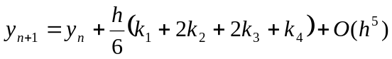, (102)

where
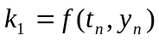, (103)
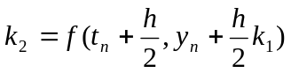, (104)
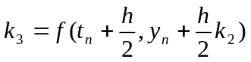, (105)
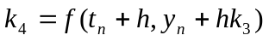. (106)

By calculating the slope at multiple points in the interval using the values, the RK4 method produces a better approximation than the Euler method.

Chapter 5 - Vehicle Network

This chapter will discuss how multiple vehicles interact at an intersection. The EKF presented last chapter depends on periodic updates to maintain correct state information. This system is designed to transmit these updates using a wireless network. First, the vehicle communication protocol will be presented. Afterwards, different wireless standards will be discussed for the protocol to communicate over. Then, the cooperative vehicle optimization algorithm will be explained.

5.1 Vehicle Communication Protocol
- how is ekf populated w/vehicles
- possible to learn about vehicles through other cars?
- Level of automation assumed and why?
- Why no human input? Local optimization

5.2 Wireless Networking Technologies (VANETs)

5.2.1 802.11g

5.2.2 WiMAX

5.2.3 DSRC\802.11p

5.3 Cooperative Vehicle Optimization Algorithm

5.3.1 Sparse Traffic

5.3.2 Dense Traffic

Chapter 6 - Stability Analysis of Vehicle Model and Network
This chapter will analyze the stability of the vehicle state equations and the optimization algorithm of the cooperative vehicle network. The results

6.1 Vehicle Model Stability

6.1.1 Equilibrium Points

6.1.2 Limit Cycles

6.2 Vehicle Optimization Algorithm Stability

Chapter 7 - Simulation Results

This chapter will present the results of simulations performed on the vehicle model and the network of vehicles. The first few sections will explain how certain constants (present overview of how simulation works in intro)

7.1 Simulation Overview
- uses matlab v?

7.2 Determination of Vehicle Model Parameters
- T
- Mair
- When to shift gears
- Rg(5)
- How did you choose the EKF update frequency? (separate section?)
- How did you choose the integration frequency? (breakdown of Euler @ 2*10-3
Why did you set parameters as such. Validate assumptions and show derivations for T, Mair….

7.3 Determining the Brake Constant of Proportionality
how Kb was determined

7.4 Determining Deceleration as a Function of Brake Angle

7.5 Comparison of the Euler and 4th-order Runge-Kutta Methods on Vehicle Model
The performance of the Euler and RK4 methods are compared when solving for 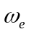. Since the vehicle velocity is directly related to , the error present in its solution figures prominently into the accuracy of the vehicle velocity. It is important to keep the errors to a minimum because the optimization algorithm needs accurate velocity information to avoid collisions. The solution of yielded by the RK4 method is shown in Fig. 4.1. The discontinuities in the plot indicate when the car shifts gears. A sample of the numerical integration results are given in Table 4.1. The data is displayed over three different time intervals to show the local and global errors. Since the model has no analytical solution, the error has been defined as the difference of the Euler from the RK4 results.

Numerical analysis is a vast field and there are many other methods available. However, the RK4 method was chosen due to its widespread popularity and accuracy.

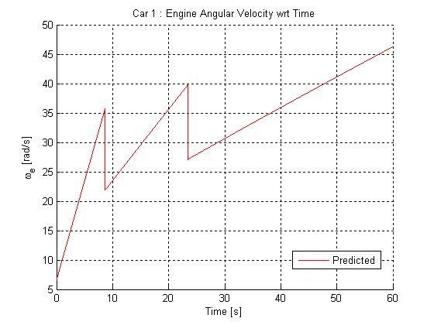

Figure 7.1: Engine Angular Velocity as a Function of Time Determined Using the RK4 Method.

Table 7.1: Numerical Integration Results
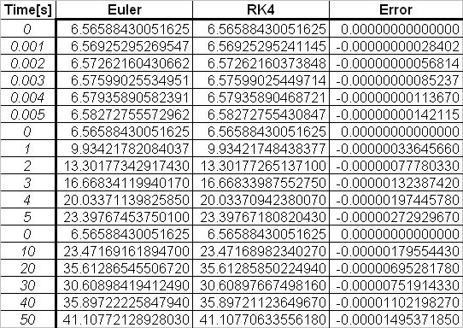

7.6 Simulations of Sparse Traffic Optimization Algorithm
- for the intersection topology and the vehicles. The topology is a flat, two-dimensional space with no elevation modeled after an intersection.
Chapter 8 - Conclusions
- Talk about future research topics
- more recent, more detailed mechanical model (hybrid)
- extend model for multiple car types
- consider different vehicle capabilities
- do wireless network analysis of VANET
- account for wireless transmission delays of observations in EKF calculation
- account for wireless errors in observation error

Chapter 9 - References
[1] Berkeley PATH engine paper
[2] Supplemental Berkeley engine paper
[Mendel]
[Gelb]
[] Gerald, C.F. and Wheatley, P.O., Applied Numerical Analysis, 6th Ed. Addison-Wesley Publishing Company, Inc, Reading, Massachusetts, 1997.
[] Grewal, M.S. and Andrews, A.P., Kalman Filtering: Theory and Practice. Prentice Hall, Inc., Englewood Cliffs, N.J. 1993.
[Jazwinski]
[] Mili, L. Robust Estimation and Filtering, Class Notes, 2007.

Appendix A

- MATLAB code

